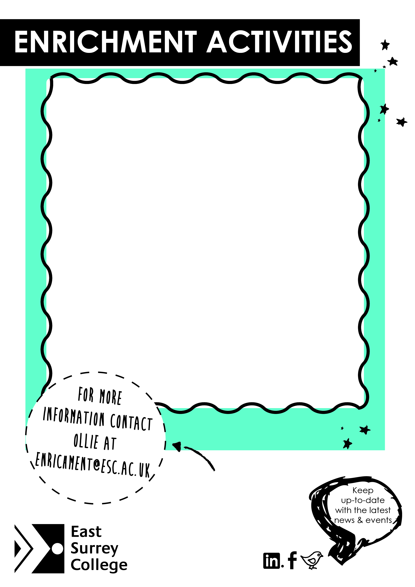

**Improve your CV**

**Volunteering**

**New Activities**

**Bouncy Gladiator Battles**

**Free Give Aways**

**Mixed Games**

**College Activity Fun Fair**

**Tuesday 29th April**

Meet us at Battlebridge Park at 12:30 – 15:00